TASKS

1. To install R1SOFT software on server (backup01.globalpsa.com) and clients (Linux and Windows Server 2012 R2 – workstation) and ensure proper execution of policies.
2. To migrate the policies running previously on the old SBM server BACKUP001.

# R1SOFT BACKUP SERVER CONFIGURATION

|  |  |
| --- | --- |
| Server Name | Backup01.globalpsa.com |
| Centos 7.3.1611 | Version 6.2.2 build 78 |
| Eth0 – 10.111.53.206/26  Eth1 – 119.81.252.211/27 |  |
| Backup directory | /data/Backups |
| Replication directory | /data/r1soft-replication-data |
| CDP Agent Listening Port | 1167 (tcp) |

# BACKGROUND

Previous backup server (backup001.globalpsa.com) was running R1SOFT version 5.12.1 build 54 was Windows Server 2012 R2. Policies (PLCY_ERMISDB001, PLCY_ERMISDB01_SQLBKP and PLCY_ERMISAPP001) were running over at the previous server.

|  |  |  |  |  |
| --- | --- | --- | --- | --- |
| Ermisapp01 | vol_ermisapp01 | DS_ ERMISAPP001 | PLCY_ERMISAPP001 |  |
| Ermisdb01 | vol_ermisdb01 | DS_ ERMISDB01 | PLCY_ERMISDB001 |  |
| Ermisdb01 | vol_ermisdb01_sqlbkp | DS_ERMISDB01SQLBKP | PLCY_ERMISDB01_SQLBKP |  |

# DOCUMENTATION

<http://wiki.r1soft.com/display/ServerBackupManager/Home>

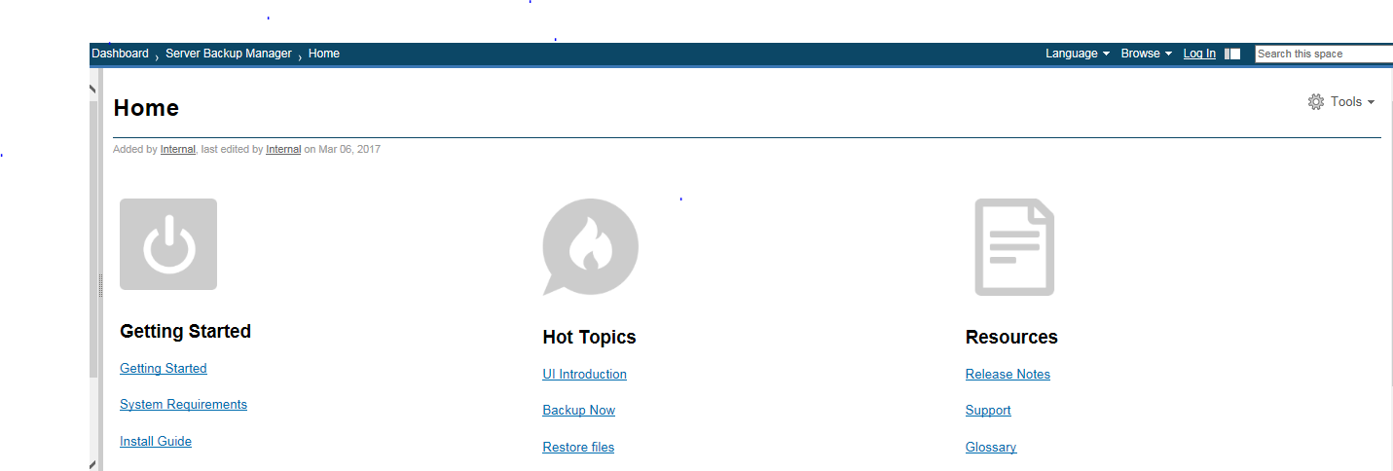

# INSTALLATION

The acronym used by R1soft on the server is SBM (Server Backup Manager) or CDP (Continuous Data Protection). The steps are documented at <http://wiki.r1soft.com/display/ServerBackupManager/Install+Server+Backup+Manager+on+CentOS%2C+RHE%2C+and+Fedora> using YUM as the server is running on Centos 7.

1. Create a yum repo file called r1soft.repo in /etc/yum.repos.d directory.

# vi /etc/yum.repos.d/r1soft.repo

**[r1soft]**

**name=R1Soft Repository Server**

**baseurl=http://repo.r1soft.com/yum/stable/$basearch/**

**enabled=1**

**gpgcheck=0**

1. Install the software using the following command

**# yum –y –disablerepo=\* --enablerepo=r1soft install serverbackup-enterprise**

1. Create an admin account with password

**# serverbackup-setup --user admin --pass <DESIRED_PASSWORD>**

1. For the web page, create listening ports for http and https daemon

**# serverbackup-setup --http-port 8080 --https-port 8443**

1. Start the R1soft on the server

# systemctl start cdp-server.service

1. Check server configuration and access using browser with port 8080. For more information, please refer to <http://wiki.r1soft.com/display/ServerBackupManager/Access+Server+Backup+Manager+web+interface>
2. Activation on the server is not needed but refer to the following for activation

<http://wiki.r1soft.com/display/ServerBackupManager/Activate+Server+Backup+Manager>

1. On the SBM server, there is a directory /usr/sbin/r1soft/log containing cdp.log, server.log and monitor.log.

|  |  |
| --- | --- |
| Cdp.log | SBM setup information |
| Server.log | Unsuccessful Login User  Agent connection  Replication of data  Snapshot  File Exclusion |
| Monitor.log | HTTP daemon job status  TOMCAT status |

# INSTALLATION ON LINUX CLIENTS

1. Create the same yum.repo file in /etc/yum.repos.d directory with the same content as in step 1 above.
2. Install the agent on the linux client using the yum program below:

**# yum –y --disablerepo=\* --enablerepo=r1soft install serverbackup-enterprise-agent**

1. Start the service

**# systemctl start cdp-agent.service**

**# systemctl enable cdp-agent.service**

**The fourth line should indicate active (running).**

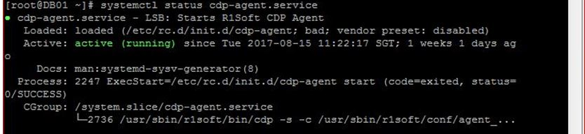

1. Check the firewall settings located in the file /etc/arp/allow_hosts to allow the agent to communicate with the server. You can check the port 1167 using nmap shown below:

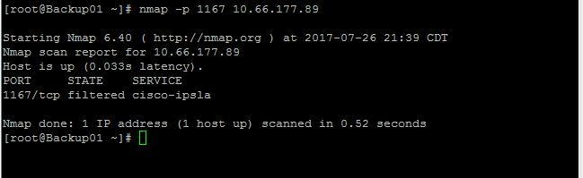

1. Test the connection between agent and server:

# r1soft-setup --test-connection

If the connection fails, please refer to the following URLs to compile the kernel module:

<http://wiki.r1soft.com/display/CDP3/Building+CDP+Kernel+Module>

<http://wiki.r1soft.com/display/ServerBackup/Build+the+Linux+Backup+Agent+kernel+module>

This testing of connection process requires an internet connection or it will fail. Alternatively, copy the kernel module from another unmodified virtual host running exact version of the kernel. There are 2 options mentioned in the URL above. Both options will create the kernel module and copy it to /lib/modules/r1soft directory.

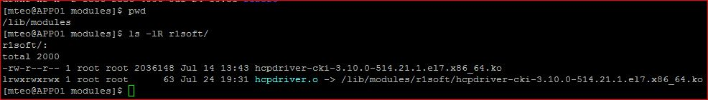

1. Restart the cdp-agent service

**# systemctl restart cdp-agent.service**

1. Test the connection (this test requires an internet connection to krnlbld.r1soft.com).

# r1soft-setup --test-connection



1. Check the key settings

# r1soft-setup --list-keys

1. If no key is listed, then issue the following command to obtain the keys from the server (10.111.53.206). The command may be different because of the IP address and the listening port running on the server.

# r1soft-setup --get-keys http://10.111.53.206:8080

1. Check the key settings again. The output must show keys registered from the R1soft server. You can also check the directory /usr/sbin/r1soft/conf/server.allow directory. It contains a file with the R1soft SBM server’s public key.
2. Also check the contents on /usr/sbin/r1soft/log directory, usually cdp.log file for the backup status.
3. Other documentation shown below

<http://wiki.r1soft.com/display/ServerBackupManager/Install+Backup+Agent+on+Linux>

# Installation on Linux Clients with MYSQL databases

Prerequisites (checklist)

The listening tcp port for mysql is 3306 while the listening port for R1soft agent is 1167. If installation fails, check the connection using nmap (Installation on Linux clients).

The mysql database on the agent has to designate a user for the R1soft backup.

Agent software for mysql

Note: for mysql databases, you need to configure replication first before backup will work.

The prerequisite for mysql databases to be backed up is the database drivers software.

<http://wiki.r1soft.com/display/kb3/Restoring+MySQL+Using+Bare-Metal+Restore>

# Installation on Windows Clients

A reboot is required after installation or you have problems connecting the r1soft to the agent.

# Installation on Windows Clients with MSSQL databases

Note: for mysql databases, you need to configure replication first before backup will work.

# Other Useful URLs

<http://wiki.r1soft.com/display/CDP3/Documentation>

<http://wiki.r1soft.com/dashboard.action>

<http://wiki.r1soft.com/display/ServerBackup/Home>